Similarities and Differences: Understanding Homology and Analogy
Name __________________________________________________________
Date Due _______________________

Use the following website to answer the questions below:
http://evolution.berkeley.edu/evolibrary/article/similarity_hs_01
- What is homology?

- What is the example described in the introduction on the first page?

- What is analogy?

- What is the example described in the introduction on the first page of the tutorial?

- What is different about the four limbs that does not belong in the grouping with the other two limbs? (select and keep clicking on the one that doesn’t belong.

- What is a tetrapod?

- What is the basic bone layout for these tetrapod limbs?

- What are the four animals that these limbs belong to?
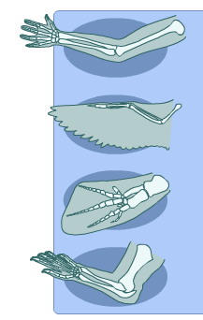

- What is a family tree?

- Structures inherited from a common ancestor are called _______________________.

- What structure on the elephant is homologous to the teeth of a beaver?

- Why are the grasshopper leg and sea star arm not homologous?

- Similar structures that evolved independently are called __________________________.

- Why do the skulls look to be homologous structures?

- How do analogous structures arise?

- What happened to the flowers over time?

- Do you think that sharks’ and dolphins’ similarities (body shape, fin, and flippers) are homologies or analogies?

- What are three criteria that biologists use to help them decide whether a shared morphological character (such as the presence of four limbs) is likely to be a homology?

- Considering all of the evidence, are the “wings” (actually flaps of skin stretched between the legs) of sugar glider and flying squirrels homologous or analogous structures?

